PRESS RELEASE
24.07.2018

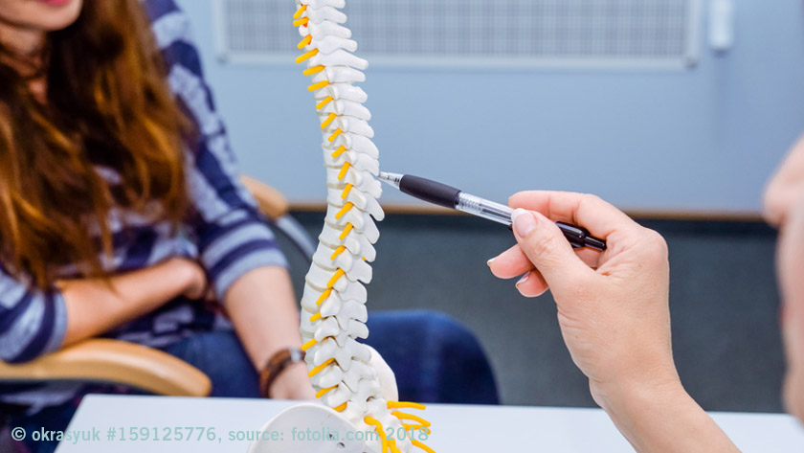
ByAxon, a success story of the European Commission funded projects

The project ByAxon, funded by the European Commission’s Horizon 2020 programme and coordinated from IMDEA Nanociencia, has been designated a success story.
ByAxon is devoted to the restoration of the signal transmission through the spinal cord by developing an innovative implant to help patients regain control and sense of their limbs. Despite the project is in an early stage and much more research is needed to take, ByAxon is shaping what might, eventually, turn out to be a major breakthrough in the treatment of paralysis.
The innovative approach to neural interfacing involves the development of a new generation of sensors and electrodes based on nanostructured materials. While its research focuses on spinal cord injuries, the partners observe that the technology could be harnessed for other types of neural interface. Examples include retinal implants, brain-recording systems for people with epilepsy, and deep-brain stimulation devices for the treatment of Parkinson’s disease.
ByAxon is an interdisciplinary consortium of 6 partners (5 research institutions IMDEA Nanociencia, CNRS-GREYC; SISSA, SESCAM, ICMM-CSIC; and 1 company mfd-Diagnostics) from 4 EU countries (Spain, France, Italy and Germany), and is funded by a Horizon 2020’s Future and Emerging Technologies (FET) programme, through a grant scheme designed to support the initial stages of research exploring radically new ideas (FET-Open), under grant agreement No. 737116.

Read the full success story in the European Commission’s Information Centre:
http://ec.europa.eu/research/infocentre/article_en.cfm?artid=49578
More information in the website of the project :
http://www.byaxon-project.eu/

